**A**

**PROJECT REPORT ON**

**THE SMART IRRIGATION SYSTEM USING IOT**

In partial fulfillment of the requirements for the award of the degree of

Submitted By

Ganji Pavani

**ABSTRACT**

In India, agriculture is the most revered and significant profession. For the majority of Indians with rural backgrounds, agriculture is their primary source of income. Intelligent irrigation aids in the growth of agricultural nations. In India, agriculture accounts for 10% of total exports and roughly 16% of GDP. The use of water is crucial in agriculture. One approach to supply water is irrigation. By missing the timings throughout this irrigation process, they waste more water. We also have a great way to save time and water called the smart irrigation system that uses IoT. We employ a number of devices, including temperature, humidity, and soil moisture sensors, as part of the smart irrigation system. These sensors will identify the varied soil conditions, and based on the percentage of soil moisture, the area will be automatically irrigated. It implies that the engine will automatically turn on when the field needs water and turn off when it has. On user devices, these sensed parameters and the state of the motor will be shown. Sensors and microcontrollers can be used to autonomously water plants by detecting when they need to be irrigated.

**INDEX**

|  |  |  |  |
| --- | --- | --- | --- |
| **S.No** | | **Contents** | **Page No** |
| 1 |  | Introduction | 1-4 |
|  | 1.1 | Introduction | 1 |
|  | 1.2 | Existing System | 2 |
|  | 1.3 | Proposed System | 2-3 |
|  | 1.4 | Literature Survey | 3-4 |
| 2 |  | System Requirements | 5-12 |
|  | 2.1 | Software and Hardware Requirements | 5 |
|  | 2.2 | ESP8266-D1 Development Board | 5-7 |
|  | 2.3 | Regulator Power Supply | 7 |
|  | 2.4 | DHT11 Sensor | 8-9 |
|  | 2.5 | Soil Moisture Sensor | 10-11 |
|  | 2.6 | Relay | 11-12 |
| 3 |  | Embedded System | 13-16 |
|  | 3.1 | Embedded System Classification | 13-14 |
|  | 3.2 | Characteristics | 15 |
|  | 3.3 | Applications | 15-16 |
| 4 |  | Design and Analysis | 17- |

|  |  |  |  |
| --- | --- | --- | --- |
|  | 4.1 | Block Diagram | 17-18 |
|  | 4.2 | Manual set-up Moder | 18 |
|  | 4.3 | Partially Automated set-up mode | 18 |
|  | 4.4 | Fully Automated set-up mode | 18 |
|  | 4.5 | Internet of Things(IoT) | 19 |
|  | 4.6 | Circuit Diagram | 19-21 |
| 5 |  | System Implementation | 22-26 |
| 6 |  | UML Diagram | 27-32 |
|  | 6.1 | Activity Diagram Theory for Smart Irrigation system using IoT | 27-31 |
|  | 6.2 | Sequence Diagram | 31 |
|  | 6.3 | Use case Diagram | 32 |
| 7 |  | Testing and Debugging | 33-41 |
|  | 7.1 | Arduino IDE | 33 |
|  | 7.2 | Steps involved | 33-41 |
|  | 7.3 | Getting Started with NodeMCU Using Arduino IDE | 35-39 |
|  | 7.4 | Arduino Sketch | 39-41 |
| 8 |  | ThingSpeak | 42-45 |
|  | 8.1 | ThingSpeak Key Features | 43 |

|  |  |  |  |
| --- | --- | --- | --- |
|  | 8.2 | Setting ThingSpeak and Getting API Key | 43-45 |
| 9 |  | Result | 46-47 |
| 10 |  | Conclusion | 48 |
| 11 |  | Future Scope | 49 |
| 12 |  | Reference | 50 |

**LIST OF SCREENS**

|  |  |  |
| --- | --- | --- |
| **Screen No** | **Title** | **Page_No** |
| 1 | Select the from tools | 33 |
| 2 | Select Ardunio tools | 34 |
| 3 | Sketch in Ardunio | 34 |
| 4 | Compile and upload | 35 |
| 5 | Choose preference | 36 |
| 6 | Select board manager url | 36 |
| 7 | Goto board | 37 |
| 8 | Goto esp | 37 |
| 9 | Select NodeMCU | 38 |
| 10 | Serial print | 39 |
| 11 | Select board | 40 |
| 12 | Compile and upload | 40 |
| 13 | Click on serial option | 41 |

|  |  |  |
| --- | --- | --- |
| 14 | Serial monitor output | 41 |
| 15 | Get API Key | 45 |
| 16 | Select mychannel | 44 |
| 17 | Activate Field | 44 |
| 18 | Save channel button | 45 |

1. **INTRODUCTION**

### Introduction:

NodeMCU based Greenhouse Environment Monitoring and controlling project use four sensors to detect the Temperature, Light, Humidity and Soil moisture sensors. Temperature Sensor is used to detect the temperature inside the greenhouse. Reading from the sensor is sent to the microcontroller. The microcontroller is connected to different relays. One of the relays is connected to a blower. If the temperature is above or below the threshold value,the microcontroller would send signals to turn ON the Fan.

Light Sensor is used to detect the amount of sunlight inside the greenhouse. Reading from the sensor is sent to the microcontroller. If the Sunlight is above the threshold value, the microcontroller would send signals to turn ON the relay which would, in real-time, be a ‘shade’ that would reduce the amount of Sunlight. For demo purposes, we have connected a DC motor to replicate a Shade.

Similarly, the Humidity sensor is used to detect the humidity value and the Soil moisture sensor (two probes dug in the soil) is used to detect the soil moisture. If the humidity value detected by the sensor is above the threshold value OR if the soil moisture reduced, the microcontroller would turn on the blower to decrease the humidity and will open the water outlet to increase the moisture in the soil. For demo purposes, we have connected a DC motor in place of blower and water outlet.

At the same time, data regarding these parameters are sent to the IOT module (ESP8266). The data sent to the IOT is sent at regular intervals irrespective of any threshold mismatch found. ESP8266 is a chip used for connecting micro-controllers to the Wi-Fi network and making TCP/IP connections and sending data. Data, which is sensed by these sensors, is then sent to the IOT. The Pre-requisite for this project is that the Wi-Fi module should be connected to a Wi-Fi zone or a hotspot.

## EXISTING SYSTEM:

Horticulture is the foundation of our Nation. In long time past days agriculturists used to figure the ripeness of soil and influenced presumptions to develop which to kind of product. They didn't think about the dampness, level of water and especially climate condition which horrible an agriculturist more. They utilize pesticides in view of a few suspicions which made lead a genuine impact to the yield if the supposition isn't right. The profitability relies upon the last phase of the harvest on which agriculturist depends.

Smart irrigation technology includes controllers and sensors that use weather data or soil moisture data to determine the irrigation need. Many sensors are compatible with existing systems and are easy to install. There are various types of sensors that can be added to an existing irrigation system, such as soil moisture sensors, temperature sensors, and water flow sensors.These sensors can detect the soil moisture level and automatically irrigate the land based on the soil moisture percentage. Smart irrigation systems using IoT are also emerging techniques that automate irrigation systems and conserve water usage Incorporating smart irrigation technology in the landscape can potentially reduce outdoor water waste, while maintaining plant health and quality.

## PROPOSED SYSTEM:

To improve the efficiency of the product there by supporting both rancher and country we need to utilize the innovation which appraises the nature of harvest and giving recommendations. The Internet of things (IOT) is revamping the agribusiness engaging the farmers by the board assortment of techniques, for instance, accuracy and conservative cultivation to go up against challenges in the field. IOT advancement aids in social affair information on conditions like atmosphere, temperature and productivity of soil, harvest web watching engages area of weed, level of water, bug acknowledgment, animal interference in to the field, alter improvement, cultivation . IOT utilize farmers to get related with his residence from wherever and at whatever point. Remote sensor frameworks are used for checking the

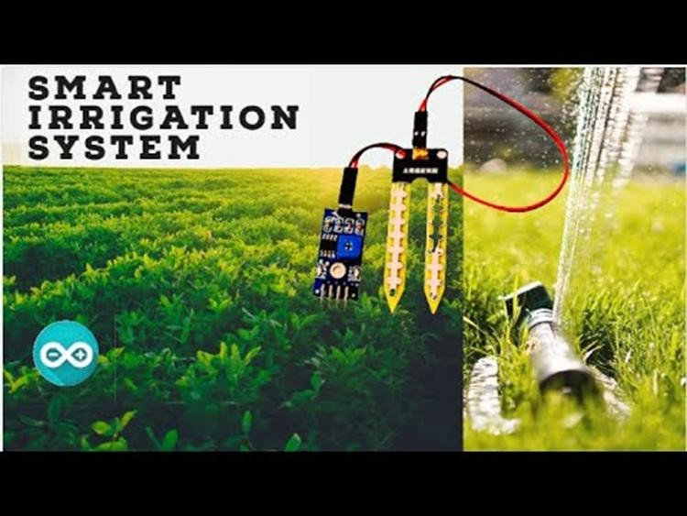

farm conditions and little scale controllers are used to control and robotize the property shapes.

Fig 1:Smart Irrigation System

## LITERATURE SURVEY:

Automated greenhouse system helps the farmers by controlling the environment parameters through the environmental parameters through the internet of things (IOT) including crop health inspection using image analysis the greenhouse is generally affected by two factors: plant diseases &weather condition, which leads to the fall in production. The weather condition can be controlled through Microcontroller Unit (MCU) & the plant diseases can be monitored using image inspection system. The research recommends cheaper image evaluation framework for the plant disease can be monitored using image inspection system. The research recommends cheaper image evaluation framework for the plant diseases analysis& fully automated greenhouse data security. The prototype of the proposed system consists of Temperature/Humidity Sensor, Moisture Sensor, &Light Sensor. The Motor, Fan Light, are controlled by NodeMCU through Relays upon reaching predetermined threshold values. The proposed architecture is equipped with embedded data security by implementing Extended Tiny Encryption Algorithms (XTEA) lastly, the agriculturists can familiarize with

the recommended framework through the cloud-centered application. The autonomous frameworks permit the agriculturists to evaluate &control their greenhouse ecology remotely.

This system consists of three main components: upper machine processors, environmental factors acquisition nodes and intelligent control terminal blockThis system realizes the functions of displaying real time data about greenhouse environment factors, data query and setting the warning value. i-learning IoT : An intelligent self-learning system for home automation using IoT, Vishwajeet Hari Bhide, Sanjeev Wagh proposed an efficient implementation for IoT (Internet of Things) used for monitoring and controlling the home appliances via World Wide Web. Automation of regular activities inside the home is home automation. Due to huge advancement in wireless sensor network and other computation technologies now a day's, it is possible to provide flexible and low cost home automation system. However there is no any system available in markets which provide home automation as well as error detection in the devices efficiently. In this system prediction is done to find out the required solution if any problem occurs in any device connected to the system. The home appliances can be controlled via Smartphone using Wi-Fi . Here raspberry pi used as server system and Wi-Fi as communication protocol.

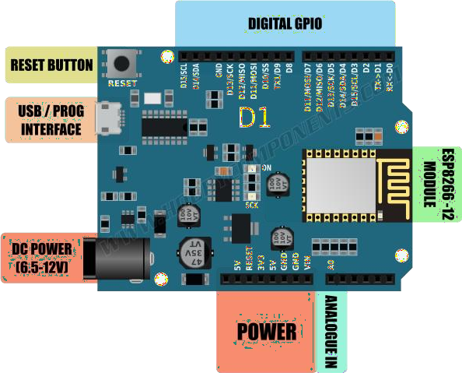

# SYSTEM REQUIREMENTS

### Software and Hardware Requirements

.

|  |  |
| --- | --- |
| **SOFTWARE** | **HARDWARE** |
| 1. Arduino   Compiler   1. Embedded C Code | 1. ESP8266 Wemos D1   Mini   1. Power Supply 2. DHT11 Sensor 3. Soil Moisture 4. AC Water Pump |

### ESP8266-D1 Development Board:

The ESP8266-D1 is a wireless 802.11 (Wi-Fi) microcontroller development board compatible with the Arduino IDE. It turns the very popular ESP8266 wireless (Wi-Fi) module into a fully-fledged development board. The layout of this board is based on a standard Arduino hardware design with similar proportions to the Arduino Uno and Leonardo. It also includes a set of standard Arduino headers which means many existing Arduino shields can be plugged directly into the board (see note below).

Fig 2.1 : ESP8266 WeMo’s D1 Mini Arduino Board Model

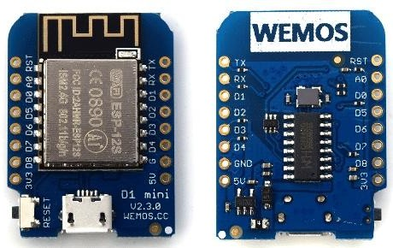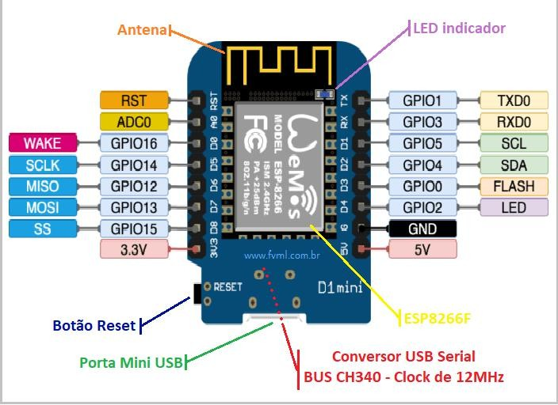

Fig 2.2 : ESP8266 WeMo’s D1 Mini Board Model

The development board also includes a CH340 USB to serial interface giving it the ability to be connected and programmed directly from your computer and requiring only a common micro USB cable – no additional interface hardware or configuring is required. Once connected to the computer, and drivers have been installed, the ESP8266-D1 will appear as a standard serial COM port. The ESP8266-D1 can be programmed directly from the Arduino Integrated Development Environment (IDE) which is freely available for download from the Arduino website (arduino.cc).

Direct Arduino IDE support for this development board can be added with just a few mouse clicks via the built-in board manager feature. Programming the ESP8266-D1 via the IDE is then as straight-forward as programming any standard Arduino development board. Many of the default Arduino commands will work including digital and analogue pin functions and many examples are included in the IDE which demonstrate how to take advantage of the ESP8266s WIFI capabilities.This 3.3V development board and is not compatible with 5V hardware. Please check comparability before purchasing Arduino shields.

Fig 2.3 : Wemos D1 Microcontroller

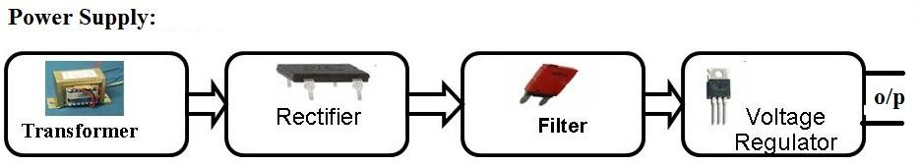

### Features:

* + - ESP8266-D1 Development Board:
    - Integrated ESP8266 module with 32-bit 80MHz microcontroller/4M flash
    - micro USB serial/programming interface
    - Can be powered via USB cable – no external PSU required
    - Arduino Compatible headers

### ESP8266 Module:

* 802.11 b/g/n
* Wi-Fi 2.4 GHz, support WPA/WPA2
* Support Smart Link Function for both Android and Iot devices
* SDIO 2.0, (H) SPI, UART, I2C, I2S, IR Remote Control, PWM, GPIO
* Deep sleep power <10uA, Power down leakage current < 5uA
* Standby power consumption of < 1.0mW (DTIM3)

## REGULATOR POWER SUPPLY

A **regulated power supply** is an embedded circuit; it converts unregulated AC into a constant DC. With the help of a rectifier it converts AC supply into DC. Its function is to supply a stable voltage (or less often current), to a circuit or device that must be operated within certain power supply limits.

Fig 2.4: Power Supply

## DHT11 SENSOR

### Introduction:

DHT11 Temperature & Humidity Sensor features a temperature & humidity sensor complex with a calibrated digital signal output. By using the exclusive digital-signal- acquisition technique and temperature & humidity sensing technology, it ensures high reliability and excellent long-term stability.

Each DHT11 element is strictly calibrated in the laboratory that is extremely accurate on humidity calibration. The calibration coefficients are stored as programmers in the OTP memory, which are used by the sensor’s internal signal detecting process. The single-wire serial interface makes system integration quick and easy. Its small size, low power consumption and up-to-20 meter signal transmission making it the best choice for various applications, including those most demanding ones. The component is 4-pin single row pin package. It is convenient to connect and special packages can be provided according to users’ request.

### How the DHT11 Measures Humidity and Temperature:

The DHT11 calculates relative humidity by measuring the electrical resistance between two electrodes. The humidity sensing component of the DHT11 is a moisture holding substrate (usually a salt or conductive plastic polymer) with the electrodes applied to the surface. When water vapor is absorbed by the substrate, ions are released by the substrate which increases the conductivity between the electrodes. The change in resistance between the two electrodes is proportional to the relative humidity. Higher relative humidity decreases the resistance between the electrodes while lower relative humidity increases the resistance between the electrodes. Inside the DHT11 you can see electrodes applied to a substrate on the front of the chip:

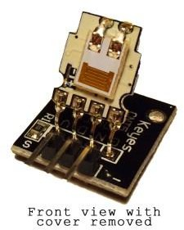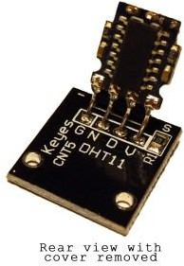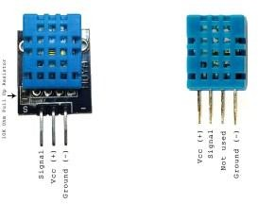

Fig 2.5: DHT11 Measures

The DHT11 converts the resistance measurement to relative humidity on an IC mounted to the back of the unit and transmits the humidity and temperature readings directly to the Arduino. This IC also stores the calibration coefficients and controls the data signal transmission between the DHT11 and the Arduino:The temperature readings from the DHT11 come from a surface mounted [NTC temperature sensor](http://buy.geni.us/Proxy.ashx?TSID=13213&GR_URL=http%3A%2F%2Fwww.amazon.com%2Fgp%2Fproduct%2FB00GD471PO%2Fref%3Das_li_qf_sp_asin_il_tl%3Fie%3DUTF8%26camp%3D1789%26creative%3D9325%26creativeASIN%3DB00GD471PO%26linkCode%3Das2%26tag%3Dcircbasi-20%26linkId%3DUJTHZ5Z3JDMKGOCK) (thermistor) built into the unit..

The DHT11 uses one signal wire to transmit sensor readings to the Arduino digitally. The power comes from separate 5V and ground wires. A 5K – 10K Ohm pull-up resistor is connected from the signal line to 5V to make sure the signal level stays high by default (see the datasheet for specifics on how the signal is sent).There are two different variations of the DHT11 sensor you might come across. One type has four pins, and the other type is mounted to a small PCB that has three pins. The PCB mounted version with three pins is nice since it includes a surface mounted 10K Ohm pull up resistor for the signal line.

Fig 2.6: DHT11 Sensor

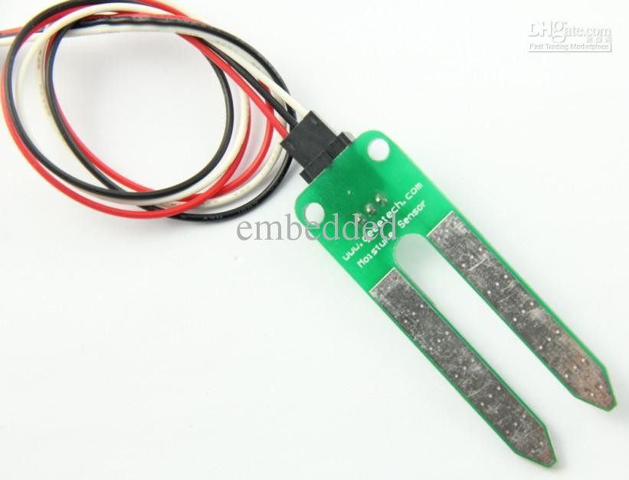

## SOIL MOISTURE SENSOR:

**Soil moisture sensors** measure the water content in soil. A soil moisture probe is made up of multiple soil moisture sensors. Since analytical measurement of free soil moisture requires removing a sample and drying it to extract moisture, soil moisture sensors measure some other property, such as electrical resistance, dielectric constant, or interaction with neutrons, as a proxy for moisture content. The relation between the measured property and soil moisture must be calibrated and may vary depending on soil type. Reflected micro wave radiation is affected by the soil moisture and is used for remote sensing in hydrology and agriculture. Portable probe instruments are used by farmers or gardeners.

Fig 2.7: Soil Moisture Sensor

A soil moisture sensor is a crucial tool in agriculture and environmental monitoring, providing valuable insights into the water content of soil. This device measures the volumetric water content in the soil, indicating the amount of water present as a percentage of the soil volume. The data gathered by these sensors aids farmers and researchers in making informed decisions regarding irrigation, optimizing water usage, and enhancing crop yield.

The sensor typically consists of two electrodes that measure the electrical conductivity or dielectric permittivity of the soil, as these properties are directly related to soil moisture. As soil moisture increases, the electrical conductivity rises, allowing the sensor to quantify the

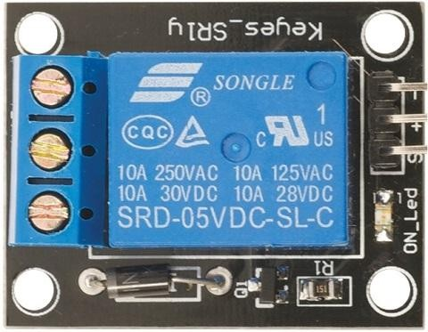

water content accurately. Some sensors utilize time-domain reflectometry (TDR) or frequency domain reflectometry (FDR) principles to achieve precise measurements.

These sensors are available in various types, including capacitance sensors, resistance-based sensors, and TDR-based sensors, each with its unique advantages and applications. Capacitance sensors are popular for their affordability and versatility, while TDR-based sensors offer high accuracy in measuring soil moisture across different soil types.

## RELAY (ELECTRO MECHANICAL SWITCH):

A relay is an electrically operated switch. Current flowing through the coil of the relay creates a magnetic field which attracts a lever and changes the switch contacts the coil current can be on or off, so relays have two switch positions and they are double throw switches.

Fig 2.8: Diagram of relay

The relay’s switch connections are usually labeled COM, NC, and NO:

* **COM=** common, always connect to this; it is the moving part of the switch.
* **NC**=normally closed, COM is connected to this when relay is off.
* **NO**=normally open, COM is connected to this when relay is on.
* Connect to COM and NO if you want the switched circuit to be on when the relay coil is on.
* Connect to COM and NC if you want the switched circuit to be on when the relay coil is off.

A Relay is a simple electromechanical switch. While we use normal switches to close or open a circuit manually, a [Relay](https://www.electronicshub.org/relay-wiring-diagram/) is also a switch that connects or disconnects two circuits. But

instead of a manual operation, a relay uses an electrical signal to control an electromagnet, which in turn connects or disconnects another circuit.

### Advantages of relays:

* Relays can switch AC and CD, transistors can only switch CD.
* Relays can switch high voltages, transistors cannot.
* Relay are a better choice for switching large currents (>5a).
* Relay can switch many contacts at once.

### Disadvantages of relays:

* Relays are bulkier than transistors for switching small currents.
* Relays cannot switch rapidly (except reed relays), transistors can switch many times per second. Relays use more power due to the current following through their coil. Relays require more current than many chips can provide, so a low power transistor may be needed to switch the current for the relays coil.

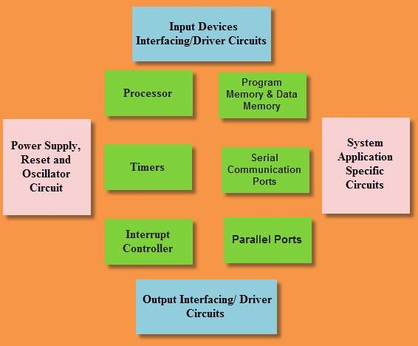

## EMBEDDED SYSTEM

It is incorporated as part of a complete device that often includes hardware and mechanical parts. Today, integrated systems control many commonly used devices. 92% of all microprocessors are produced as integrated components of the system.

Fig 3.1: Embedded Systems Design

Typically incorporated computer property examples, compared to general-purpose counterparts, are low energy consumption, reduced size, variable performance, and low-cost unit cost. However, by building intelligence mechanisms at the top of the hardware, using existing sensors and the existence of an integrated network can best manage the available network and group resources. For example, intelligent techniques can be designed to manage the energy consumption of embedded systems.

Modern systems often incorporate built-in microcontrollers (CPUs or peripheral memory interfaces), but common microprocessors are commonly used (using external chip memory interfaces and peripheral circuits), especially in more complex systems. In any case, the processor or processors can be used typed that goes from the general purpose specialized in some types of calculations, or even designed for the application. A common standard of dedicated processors is the digital signal processor (DSP).

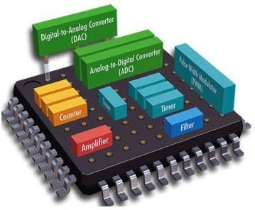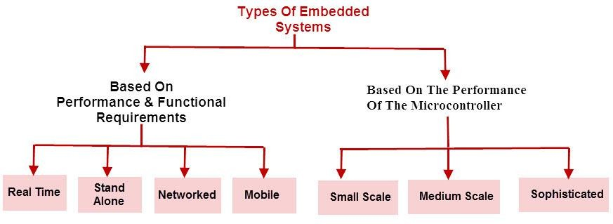

Fig 3.2: Embedded System Hardware

Because the integrated system is dedicated to specific tasks, designers can optimize to reduce the size and cost of the product and increase reliability and performance. Some embedded systems are serially produced, benefiting from economies of scale.

Integrated systems range from portable devices such as digital clocks and MP3 players to large stationary systems such as traffic lights, factory controllers and large complex systems such as hybrid vehicles, magnetic resonance imaging, and avionics. Complexity varies from low to high, with a single microcontroller chip, with the largest number of drives, peripherals, and networks mounted within a large frame or fence.

## EMBEDDED SYSTEM CLASSIFICATION:

Fig 3.4: Classification of Embedded Systems

Embedded systems are mainly classified into different types based on hardware and software complexity and microcontrollers (8 or 16 or 32 bits).Therefore, based on the performance of the microcontroller, embedded systems are classified into three types, such as:

* Small-scale embedded systems
* Medium-scale recessed systems
* Integrated sophisticated systems

In addition, based on the performance and functional requirements of the integrated system, divided into four types, such as:

* Embedded systems in real time
* Embedded independent systems
* Integrated network systems
* Integrated mobile system

## CHARACTERISTICS:

* Embedded systems are designed to perform some specific tasks rather than being a general- purpose multitasking computer. Some also have real-time performance constraints that must be met, for reasons such as security and usability; others may have low or nonexistent performance requirements, simplifying system hardware to reduce costs.
* Embedded systems are not always separate devices. Many embedded systems consist of small parts within a larger device that serves a more general purpose. For example, the Gibson Robot Guitar has an integrated system for adjusting strings, but the overall purpose of the Robot Guitar is obviously to play the music. Likewise, a built-in system in a car provides a specific function as a car subsystem.

## APPLICATIONS:

Embedded systems are commonly found in consumer, kitchen, industry, automotive, medical, commercial, and military applications.

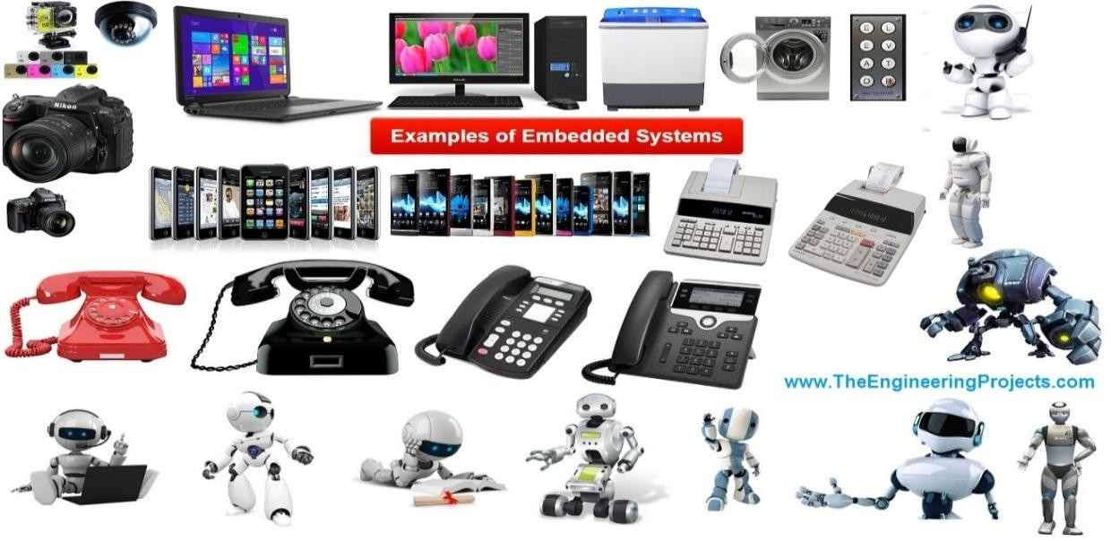

Telecommunication systems employ a number of integrated phone network switching systems for end-user mobile phones. The computer network uses dedicated routers and network bridges for the data path.

Figure 3.5: Real-life examples of Embedded System

# DESIGN AND ANALYSIS

The greenhouse system comprises the monitoring area and the control area. A DHT11 sensor, an LDR sensor, a moisture sensor on the floor and a flame sensor track environmental parameters are included in the control portion. ESP8266 is used to submit IOT cloud systems with environmental parameters. A fan, water pump and artificial light are in the control area. The heart of the machine is the Arduino microcontroller.

In this effort, The Arduino is the standard controller used to connect all sensors to each other. To detect the temperature inside the greenhouse the temperature sensor is used. The microcontroller receives the sensor readings. All of these relays is connected to the Buzzer. If the temperature exceeds the threshold level, the microcontroller transmits signals to activate the fan. LDR sensor for detecting the intensity of sunlight in the greenhouse. The microcontroller sends signals using artificial light to increase the strength of light if the amplitude is below the threshold value. The microcontroller can transmit signals using artificial light to increase the light intensity when the amplitude is below the threshold value. The moisture sensor is used to detect moisture and the soil moisture sensor is used to detect moisture from the soil. If the sensor's measured humidity value is above the threshold value, Using a water pump, water is transferred. If soil moisture is limited, the buzzer will be turned on by the microcontroller to decrease moisture and open the water outlet to increase soil moisture. Data on these parameters would be sent to the IOT module at the same time (ESP8266).

## BLOCK DIAGRAM:

### Power Supply Soil Moisture DHT11Sensor

## ESP8266 WEMOS D1 MINI

### Relay Motor

Fig 4.1: Block Diagram

### Current Scenario:

Greenhouses in India are now commonly found even in remote locations. However it is an essential requirement to grow plant in extreme climatic conditions not suited for plant growth. For example in high altitude regions where the temperature can be as low as -40° C, any kind of plantation is almost impossible. The existing greenhouse set-ups can be primarily classified amongst three types as- Manual set-up mode, partially automated set-up mode, and fully automated setup mode.

### Manual set-up mode:

This set-up involves visual inspection of the plant growth, manual irrigation of plants, turning ON and OFF the temperature controllers, manual spraying of the fertilizers and pesticides. It is time consuming, vulnerable to human error and hence less accurate and unreliable.

### Partially automated set-up mode:

This set-up is midway between manual set-up mode and fully automated set-up mode. In this mode, the user of the system can get messages if the parameters values goes beyond the threshold and then user can manually take any kind of control measure like turning on the water pump. This mode will can reduce the labor workforce to some extent.

### Fully automated set-up mode:

This is a sophisticated set-up mode which is well equipped to react to the climatic changes that occur inside the greenhouse and also to produce a fast quick efficient result with respect to the human expectation. It works on the feedback system which gives a benefit to respond to the external stimuli efficiently. Automated set-up system will avoid the errors that are done by

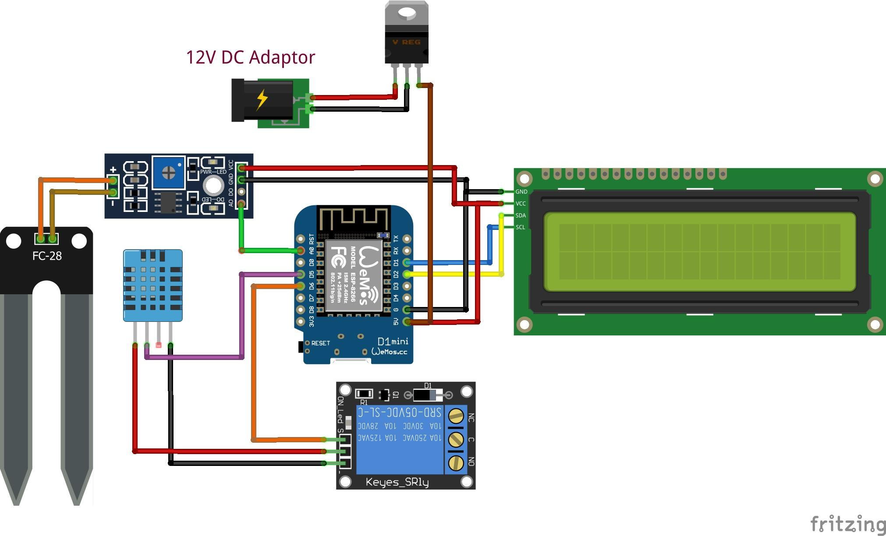

the human. Presently for developing such kind of fully automated set-up mode the best supporting technology is IoT.

### Internet of things (IoT):

IoT is not only a theoretical concept but also a practical reality. Currently the operation of the IoT is in such a way that machine communicates with machine and devices through embedded sensors. The development of IoT has significantly changed scenario of infrastructure of the network. A survey estimates that by 2020 there will be 26 billion devices connected to IoT.

### Circuit Diagram:

Fig 4.2 : Circuit Diagram of a Smart Irrigation System

### Technology:

Technologies commonly used in soil moisture sensors include:

-[Frequency domain sensor](http://en.wikipedia.org/wiki/Frequency_domain_sensor) such as a capacitance sensor.

-[Neutron moisture gauges](http://en.wikipedia.org/wiki/Neutron_moisture_gauge), utilize the moderator properties of water for neutrons.

-Electrical resistance of the soil

-[Tensiometer](http://en.wikipedia.org/wiki/Tensiometer_(soil_science))

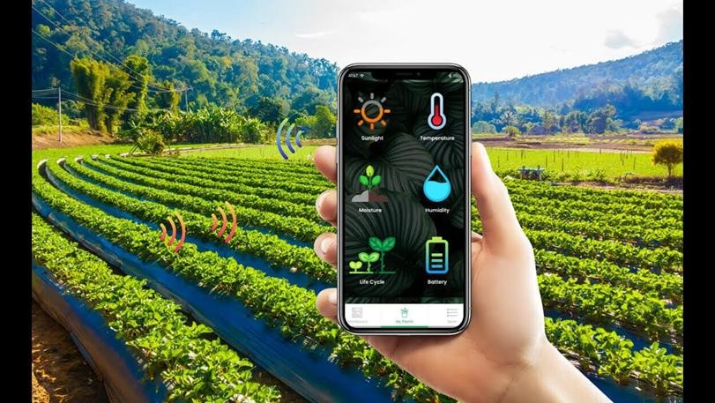

### Agriculture:

Measuring soil moisture is important in agriculture to help farmers manage their irrigation systems more efficiently. Not only are farmers able to generally use less water to grow a crop, they are able to increase yields and the quality of the crop by better management of soil moisture during critical plant growth stages.

Besides agriculture, there are many other disciplines using soil moisture sensors. Golf courses are now using sensors to increase the efficiencies of their irrigation systems to prevent over watering and leaching of fertilizers and other chemicals offsite.

Fig 4.3: Smart Irrigation

### Landscape irrigation:

In urban and suburban areas, landscapes and residential lawns are using soil moisture sensors to interface with an irrigation controller. Connecting a soil moisture sensor to a simple irrigation clock will convert it into a "smart" irrigation controller that prevents an irrigation cycle when the soil is wet.

### Simple sensors for gardeners:

Cheap and simple devices are available for checking whether plants have sufficient moisture to thrive that do not require a power source. After inserting a probe into the soil for approximately 60 seconds a meter indicates if the soil is too dry, moist or wet for plants.Use of IoT for greenhouse automation has resulted in a great benefit in terms of remote monitoring and graphical representation of parameters. The implementation is carried out by designing a microcontroller-based system which monitors and records the values of various parameters such as temperature , humidity.All these values are continually monitored and controlled in an order to get maximum yield. We have created a webpage on which we can observe the real time data of different sensors.

# SYSTEM IMPLEMENTATION

#include <ESP8266WiFi.h> #include <Wire.h>

#include <LiquidCrystal_I2C.h> #include <DHT.h>

LiquidCrystal_I2C lcd(0x27, 16, 2);

String apiKey = "M9CZDTWH78YX3RU9";

const char *ssid = "SmartIrrigation"; const char *pass = "Smart123";

const char* server = "api.thingspeak.com";

#define DHTPIN 12 #define SoilPin A0 #define led 2

#define relay 14

#define DHTTYPE DHT11 DHT dht(DHTPIN, DHTTYPE);

WiFiClient client;

void setup()

{

Serial.begin(9600); pinMode(led, OUTPUT); pinMode(relay, OUTPUT);

digitalWrite(relay, HIGH); pinMode(SoilPin, INPUT); lcd.init();

lcd.backlight(); lcd.print("Smart Irrigation"); lcd.setCursor(0, 1); lcd.print(" System "); delay(2000);

lcd.clear();

lcd.print(" using "); lcd.setCursor(0, 1); lcd.print("IOT & ThingSpeak"); delay(1500);

Serial.println("Connecting to Internet"); Serial.println(ssid);

WiFi.begin(ssid, pass); lcd.clear(); lcd.print("Connecting to");

while (WiFi.status() != WL_CONNECTED)

{

delay(500); lcd.setCursor(0, 1); lcd.print(ssid); Serial.println("Wait... ");

}

Serial.println("WiFi Connected ");

lcd.clear();

lcd.print("WiFi Connected"); lcd.setCursor(0, 1); lcd.print(WiFi.localIP()); digitalWrite(led, HIGH);

delay(500); digitalWrite(led, LOW); delay(500); digitalWrite(led, HIGH); delay(500); digitalWrite(led, LOW); delay(500);

dht.begin();

}

void loop()

{

int temp, hum, water;

float t = dht.readTemperature(); temp = t;

float h = dht.readHumidity(); hum = h;

water = analogRead(SoilPin);

water = map(water, 0, 1024, 0, 100); delay(300);

lcd.clear(); lcd.print("T: "); lcd.print(temp);

lcd.setCursor(8, 0); lcd.print("H: "); lcd.print(hum); lcd.setCursor(0, 1); lcd.print("Water: "); lcd.print(water); delay(1000);

if (water > 80)

{

digitalWrite(relay, LOW); Serial.println("Water Level Low! Motor ON"); delay(1000);

}

if (water < 40)

{

digitalWrite(relay, HIGH); Serial.println("Water Level High! Motor OFF"); delay(1000);

}

lcd.clear(); lcd.print("Uploading... "); delay(1000);

if (client.connect(server, 80)) // "184.106.153.149" or api.thingspeak.com

{

String postStr = apiKey; postStr += "&field1="; postStr += String(t); postStr += "&field2="; postStr += String(h); postStr += "&field3="; postStr += String(water); postStr += "\r\n\r\n\r\n";

client.print("POST /update HTTP/1.1\n"); client.print("Host: api.thingspeak.com\n"); client.print("Connection: close\n");

client.print("X-THINGSPEAKAPIKEY: " + apiKey + "\n"); client.print("Content-Type: application/x-www-form-urlencoded\n"); client.print("Content-Length: ");

client.print(postStr.length()); client.print("\n\n"); client.print(postStr);

Serial.println(" Data Sent ");

lcd.setCursor(0, 1); lcd.print("-- Data Sent -- "); delay(1000);

delay(500);

}

else

{

Serial.println("Data not Upload"); lcd.setCursor(0, 1); lcd.print("-- Data Error --"); delay(500);

}

client.stop(); delay(1000);

}

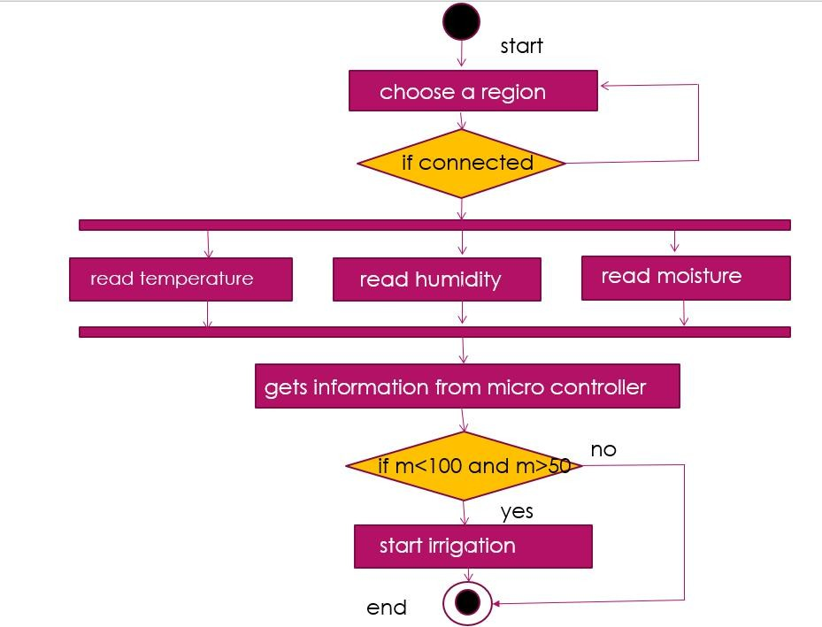

# UML DIAGRAMS

### Activity Diagram Theory for Smart Irrigation System using IoT:

A Smart Irrigation System using the Internet of Things (IoT) involves the integration of sensors, actuators, and communication technologies to optimize water usage in agriculture.

Fig 6.1:Activity diagram

The activity diagram illustrates the dynamic aspects of the system, depicting the flow of activities and interactions between components. Here is the theory explained:

### User Initialization:

**Activity:** The diagram begins with the user initializing the system, either through a mobile application or a web interface.

**Explanation:** This activity represents the user's interaction with the Smart Irrigation System. The user may set preferences, view sensor data, or manually control irrigation parameters.

### Sensor Data Acquisition:

**Activity:** Sensors continuously collect data on soil moisture, weather conditions, and other relevant parameters.

**Explanation:** This activity reflects the automated process of gathering environmental data essential for effective irrigation decision-making. Sensors transmit real-time information to the system.

### Data Processing:

**Activity:** The system processes the incoming sensor data.

**Explanation:** Algorithms analyze soil moisture levels, weather forecasts, and historical data to determine the optimal irrigation schedule. This activity involves decision-making logic based on predefined rules or machine learning algorithms.

### Decision Making:

**Activity:** The system makes decisions on when and how much to irrigate. **Explanation:** Considering the processed sensor data, the system decides whether irrigation is required. If so, it determines the appropriate amount of water and activates actuators to control irrigation.

### Actuator Control - Irrigation:

**Activity:** Actuators control irrigation valves or pumps.

**Explanation:** If the decision-making process indicates the need for irrigation, this activity triggers actuators to open or close valves, controlling the flow of water to the fields. The duration and amount of water are based on the system's decision.

### Feedback to User:

**Activity:** The system provides feedback to the user.

**Explanation:** Users receive notifications or updates on irrigation activities through the interface. This could include summaries of irrigation schedules, soil conditions, and water usage reports.

### Manual Override:

**Activity:** Users have the option to manually override the system.

**Explanation:** If necessary, users can manually adjust irrigation settings through the interface. This activity ensures flexibility and user control, allowing for adjustments based on on-the-ground observations.

### System Monitoring:

**Activity:** Continuous monitoring of the system's components.

**Explanation:** The system monitors sensor health, communication status, and actuator functionality. This ongoing activity ensures the reliability and integrity of the Smart Irrigation System.

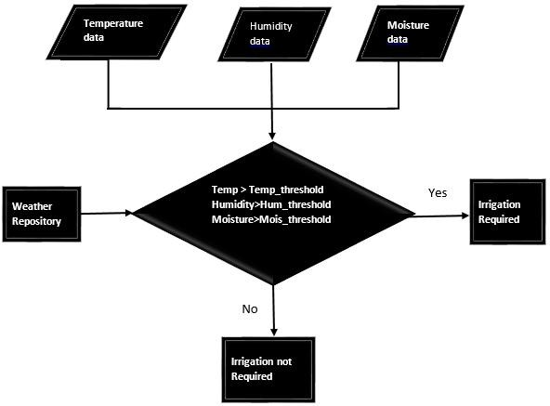

### End of Operation:

**Activity:** The diagram concludes when the user exits the system.

**Explanation:** This activity represents the end of the user's interaction with the Smart Irrigation System. The system may continue to operate autonomously based on predefined algorithms until the next user interaction.

This activity diagram provides a theoretical overview of the dynamic processes involved in a Smart Irrigation System using IoT, showcasing the interaction between users, sensors, actuators, and the decision-making logic that optimizes water usage in agriculture.

Fig 6.2: Unified Modeling Language

In Unified Modeling Language (UML), a Smart Irrigation System can be represented using several diagrams. The Class Diagram illustrates the system's structure, showcasing classes like 'Sensor,' 'Actuator,' and 'User' along with their relationships. Attributes and methods define the properties and functionalities of each class.

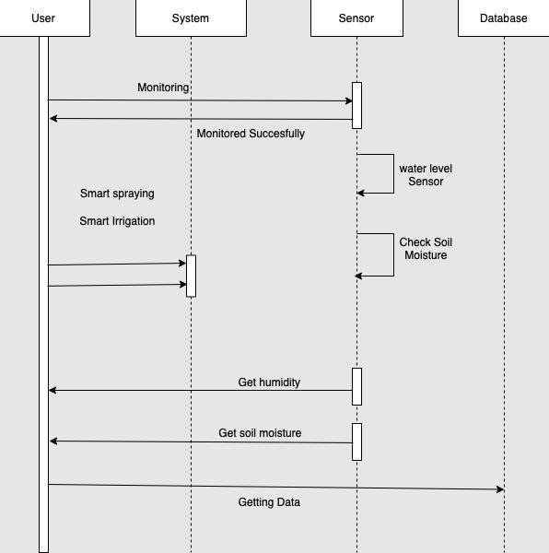

The Activity Diagram captures the dynamic aspects of the system. It portrays the flow of activities from user initialization to sensor data acquisition, decision-making, actuator control, and feedback. Decision nodes and swimlanes demonstrate the system's decision logic and user interactions.

Furthermore, the Use Case Diagram outlines various functionalities from a user's perspective, including 'Monitor Soil Moisture,' 'Adjust Irrigation Settings,' and 'Receive Notifications.' Actors like 'User' and 'Sensor' interact with these use cases.

These UML diagrams collectively provide a comprehensive theoretical representation of the Smart Irrigation System, offering insights into its structure, behavior, and user interactions in a visual and standardized manner.

# Sequence diagram:

Fig 6.3:Sequence diagram

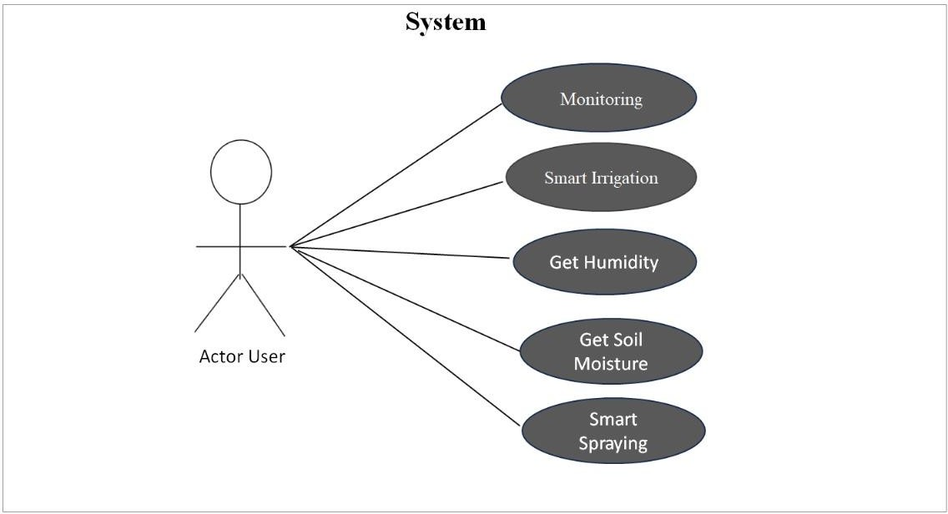

Creating a sequence diagram for a smart irrigation system using IoT involves illustrating the interactions and messages exchanged between different components or actors in the system. In this case, you might have various elements such as sensors, controllers, a cloud platform, and possibly a mobile application

# Use Case Diagram:

Fig 6.4: Use case diagram

This use case diagram illustrates the main interactions and functionalities of the smart irrigation system using IoT. Keep in mind that use case diagrams are simplified and may not capture all the details of the system. Additional details, such as system boundaries, dependencies, and specific functionalities, can be included based on the specific requirements of your smart irrigation system.

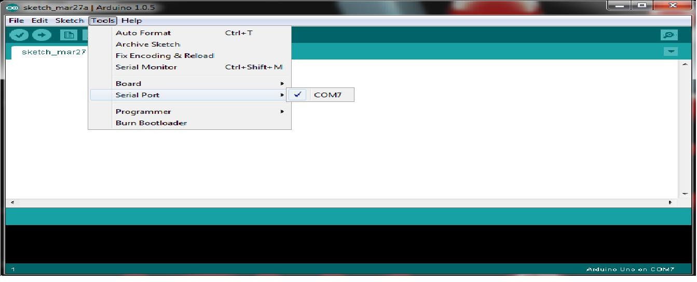

# TESTING AND DEBUGGING

## ARDUINO IDE:

The Arduino integrated development environment (IDE) is a cross-platform application written in Java, and is derived from the IDE for the Processing programming language and the Wiring projects. It includes a code editor which is capable of compiling and uploading programs to the board with a single click. A program or code written for Arduino is called a "sketch”.

### Following are the steps involved:

1. **Open Arduino IDE as shown below:**

Arduino programs are written in C or C++. The Arduino IDE comes with a software library called "Wiring" from the original Wiring project, which makes many common input/output operations much efficient. Users only need define two functions to make a runnable cyclic executive.

### Procedure:

setup(): a function run once at the start of a program that can initialize settings loop(): a function called repeatedly until the board powers off.

### Select the from tools:

Screen 1 :select tool

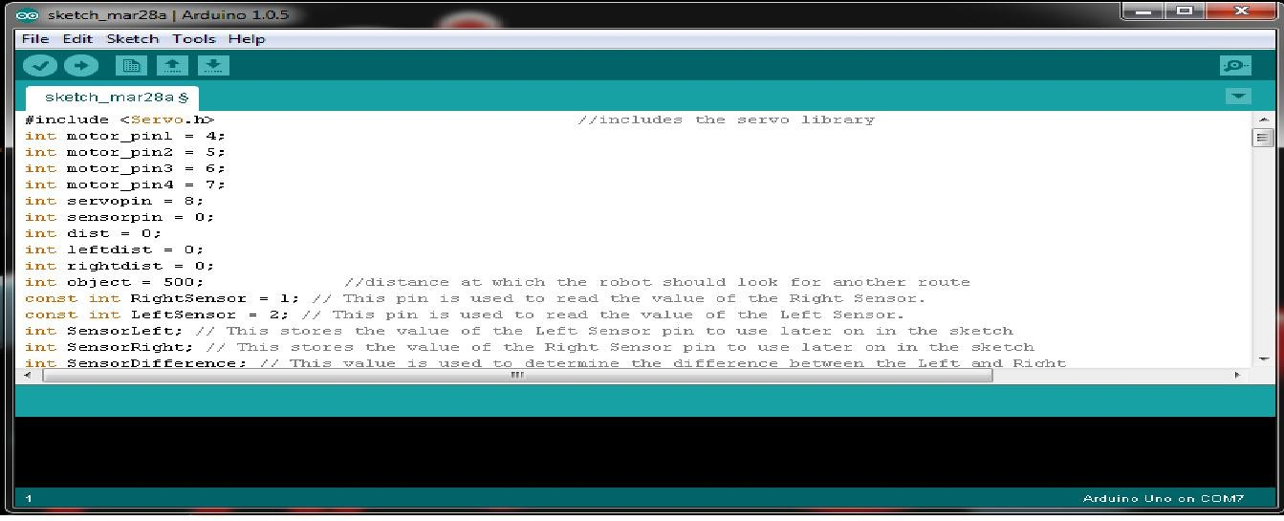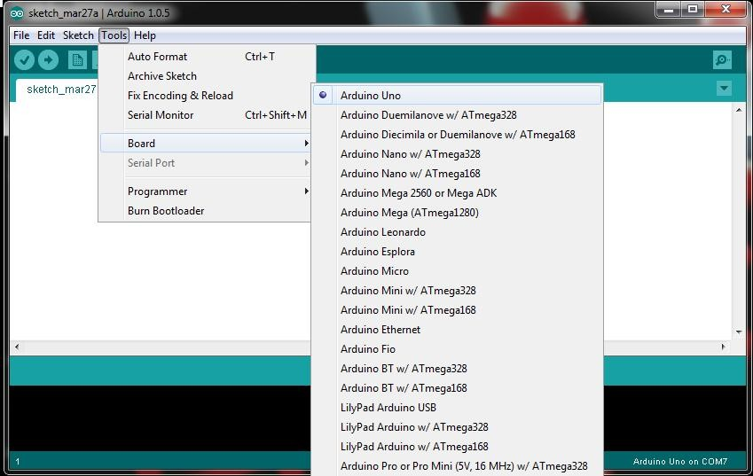

### Select the required Arduino board from Tools:

Screen 2 :select Ardunio Uno

### Write the sketch in Arduino IDE:

Screen 3 :sketch in Arduino IDE

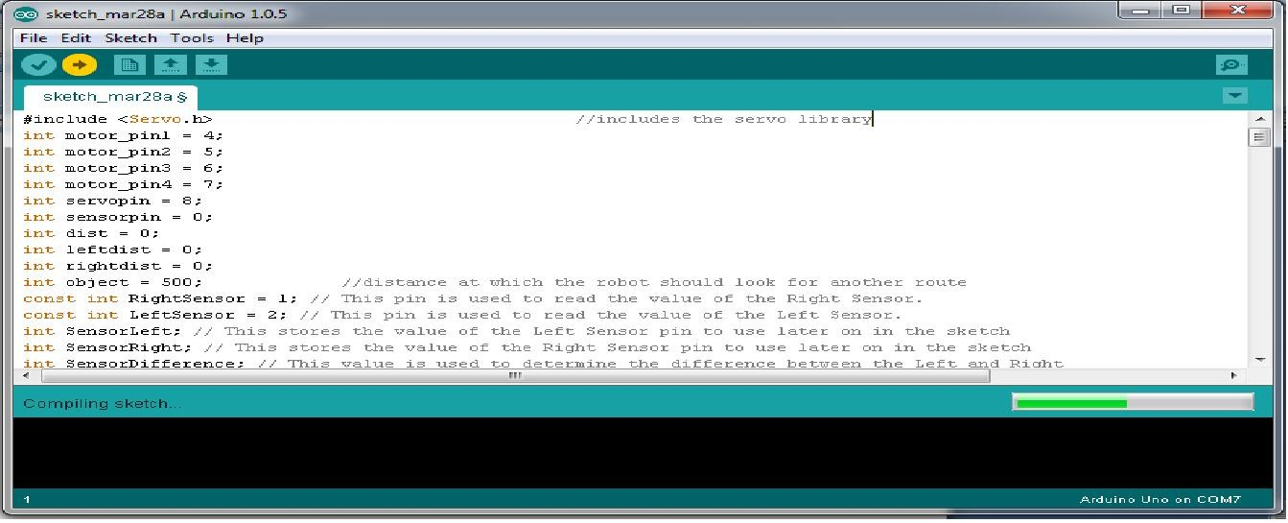

### Compile and upload the Sketch to Arduino board:

Screen 4: compile and upload

### Getting Started With NodeMCU Using Arduino Ide:

**Introduction:**

NodeMCU is Lua based firmware of ESP8266. Generally, ESPlorer IDE is referred for writing Lua scripts for NodeMCU. It requires to get familiar with ESPlorer IDE and Lua scripting language.

There is another way of developing NodeMCU with a well-known IDE i.e. Arduino IDE. We can also develop NodeMCU applications using Arduino development environment. This makes things easy for Arduino developers than learning new language and IDE for NodeMCU.

Let’s see about setting up Arduino IDE with NodeMCU. First**DownloadArduinoIDE(version1.6+)** <https://www.arduino.cc/en/Main/Software>

* **Open Arduino IDE** and **Go to File -> Preference**.

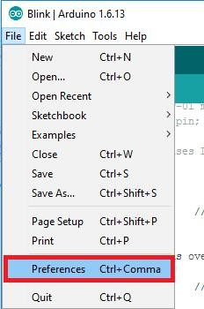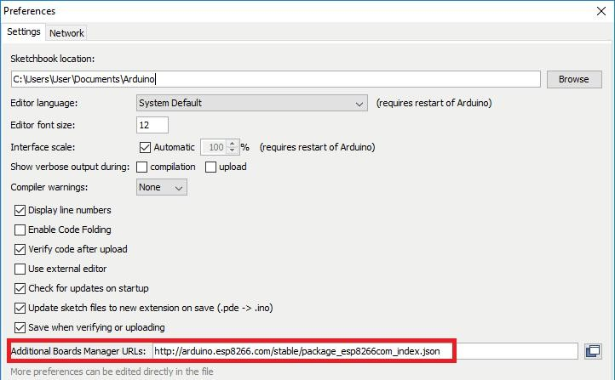

Screen 5: choose preferences

* Now on Preference window, **Enter below link in Additional Boards Manager URLs**

<http://arduino.esp8266.com/stable/package_esp8266com_index.json>

Screen 6: select board manager url

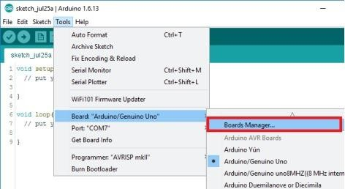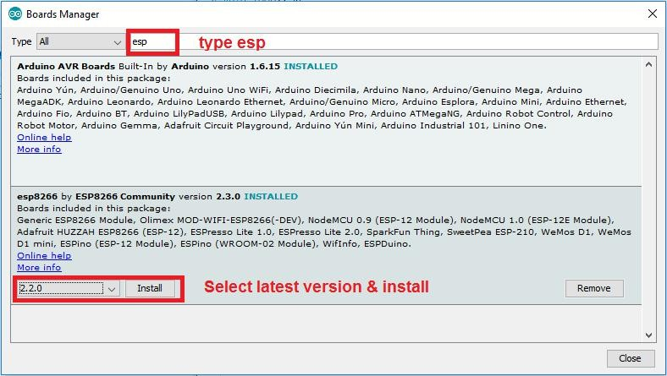

Now close Preference window and **go to Tools -> Board -> Boards Manager**

Screen 7: goto board

* In Boards Manager window**, Type esp in the search box, esp8266 will be listed there below. Now select latest version of board and click on install.**

Screen 8: goto esp

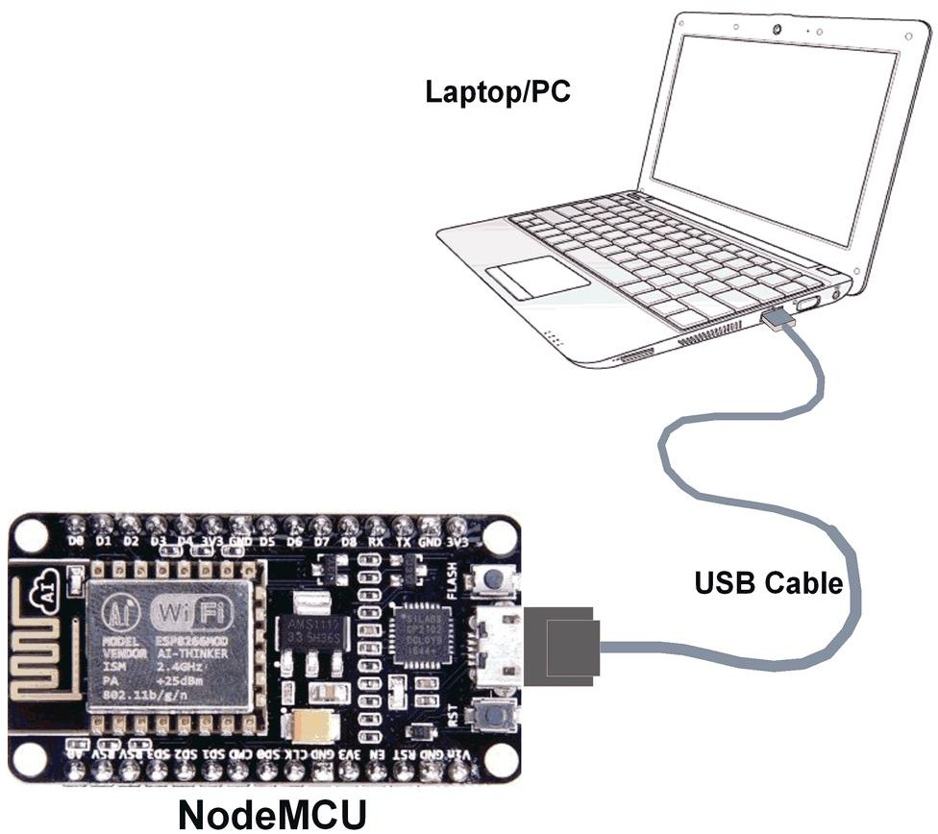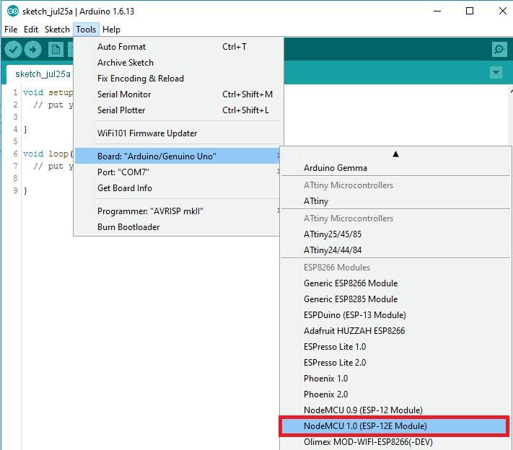

* After installation of the board is complete, **open Tools->Board->and select NodeMCU 1.0 (ESP-12E Module).**

Screen 9 : select NodeMCU 1.0

Now Your Arduino IDE is ready for NodeMCU.

### Example:

Let’s see how to write simple serial print sketch using Arduino IDE for NodeMCU. First connect NodeMCU Development Kit with PC as shown in below figure.

Fig 7.1: Node MCU Development

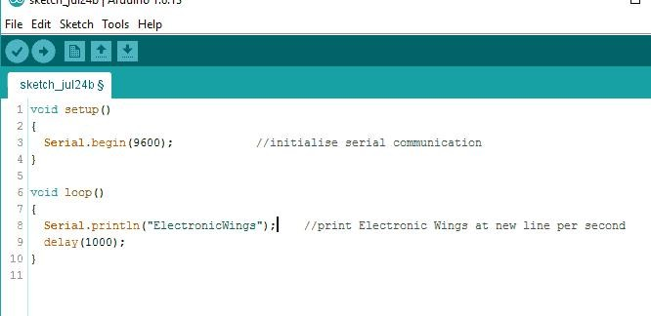

### NodeMCU connection with PC:

After setting up Arduino IDE for NodeMCU, **open Arduino IDE and write simple sketch of serial print** as shown in below figure.

Screen 10: serial print

### Arduino Sketch:

void setup() {

Serial.begin(9600); /* initialise serial communication */

}

void loop() {

Serial.println("Smart Shopping Cart System");

/* print Electronic Wings at new line per second */ delay(1000);

}

Ensure that you have selected the correct board **as shown in below figure. Also** make sure that you have selected the appropriate COM port**.**

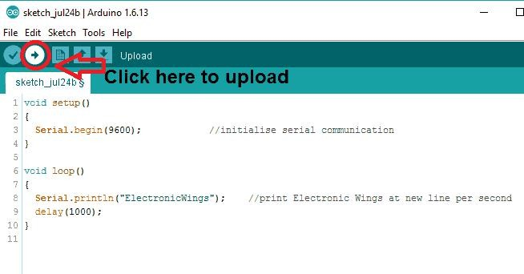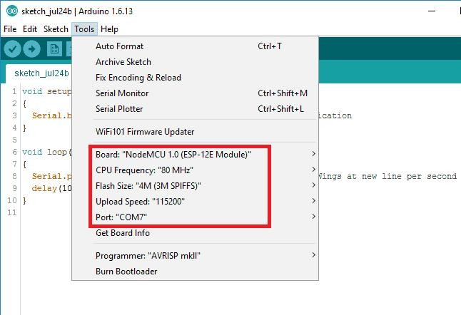

Screen 11.select board

Now **compile & upload the written sketch** directly to the NodeMCU Dev Kit by clicking on upload button.

Screen 12: compile and upload

Now **Click on Serial Monitor (upper right corner) option** to check output on serial monitor window of Arduino IDE.

Serial monitor output window will pop up with output as shown in below figure.

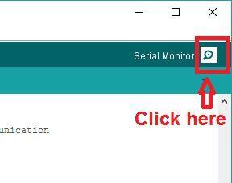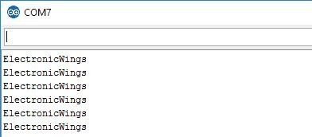

Screen 13: click on serial option

Serial monitor output window will pop up with output as shown in below figure.

Screen 14: serial monitor output

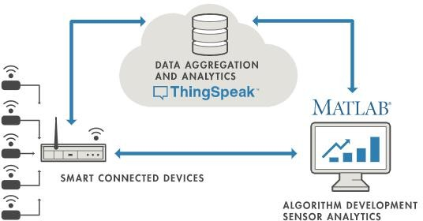

# THINGSPEAK

ThingSpeak is an IoT analytics platform service that allows you to aggregate, visualize and analyze live data streams in the cloud. ThingSpeak provides instant visualizations of data posted by your devices to ThingSpeak. With the ability to execute MATLAB® code in ThingSpeak you can perform online analysis and processing of the data as it comes in. ThingSpeak is often used for prototyping and proof of concept IoT systems that require analytics.

### What is IoT?

Internet of Things (IoT) describes an emerging trend where a large number of embedded devices (things) are connected to the Internet. These connected devices communicate with people and other things and often provide sensor data to cloud storage and cloud computing resources where the data is processed and analyzed to gain important insights. Cheap cloud computing power and increased device connectivity is enabling this trend.

At a high level, many IoT systems can be described using the diagram below:

Fig 8.1: IOT Systems

On the left, we have the smart devices (the “things” in IoT) that live at the edge of the network.In the middle, we have the cloud where data from many sources is aggregated and



analyzed in real time, often by an IoT analytics platform designed for this purpose.The right side of the diagram depicts the algorithm development associated with the IoT application. In this case, the data is pulled from the IoT platform into a desktop software environment .

An IoT system includes all these elements. ThingSpeak fits in the cloud part of the diagram and provides a platform to quickly collect and analyze data from internet connected sensors.

### ThingSpeak Key Features:

ThingSpeak allows you to aggregate, visualize and analyze live data streams in the cloud. Some of the key capabilities of ThingSpeak include the ability to:

* Easily configure devices to send data to ThingSpeak using popular IoT protocols.
* Visualize your sensor data in real-time.
* Aggregate data on-demand from third-party sources.
* Use the power of MATLAB to make sense of your IoT data.
* Run your IoT analytics automatically based on schedules or events.
* Prototype and build IoT systems without setting up servers or developing web software.

### Setting ThingSpeak & Getting API Key:

* Go to https://thingspeak.com/ and create an account if you do not have one. The registration process on the ThingSpeak IoT platform is very simple. After your account is ready.
* Login to your account

Screen 15: get API key

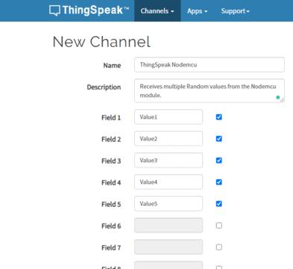

Click on the Channels menu and then click on the New Channel. This will open a new page as you can see in the picture below.

Screen 16: select my channel

I selected the name as ThingSpeak Nodemcu and followed by the description. To activate a field, simply click on the check box, and you can assign different names to the fields, I selected Value1 to Value5.

Screen 17: activate field

Scroll down, check the show status check box, and click on the Save Channel Button. For now you can forget about other fields. So, after you click on the Save button, a new page will open as you can see in the picture below

As you can see the channel name at the top “ThingSpeak Nodemcu”. The Channel ID:1088758, and other things. All the selected fields are automatically added, if you scroll down the page. To Copy the API Keys, click on the API Keys

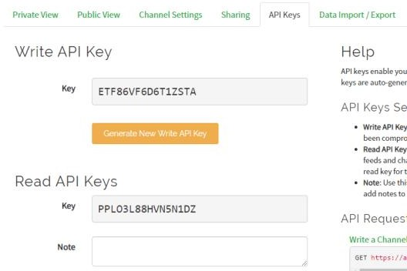

Screen 18: save channel button

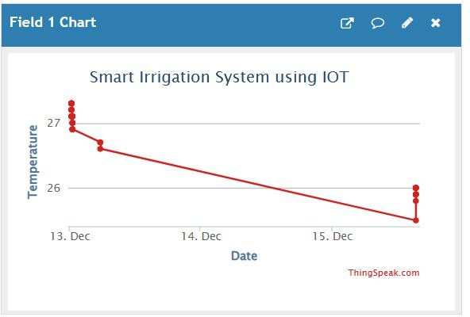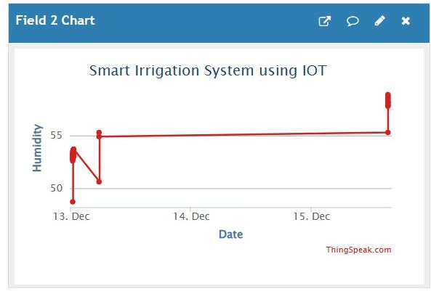

# RESULT

### Projects Result Images:

Fig 9.1: Temperature

Fig 9.2: Humidity

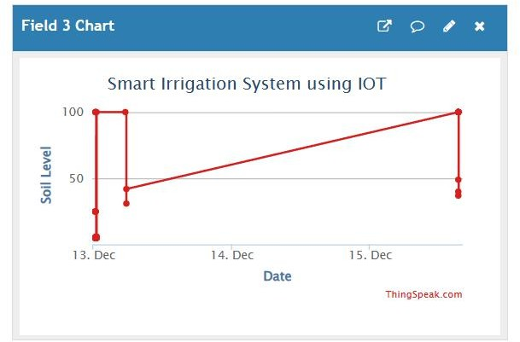

Fig 9.3: Soil Moisture

# CONCLUSION

The smart irrigation system implemented is cost effective for optimizing water resources for agricultural production. The proposed system can be used to switch on/off the water sprinkler depending on the soil moisture levels thereby making the process simpler to use. Through this project it can be concluded that there can be considerable development in irrigation with those of IOT and automation. Thus this system is a solution to the problems faced in the existing process of irrigation.

In conclusion, the implementation of smart irrigation systems utilizing Internet of Things (IoT) technology represents a significant advancement in agricultural practices. By seamlessly integrating sensors, actuators, and data analytics, these systems enable farmers to optimize water usage, enhance crop yields, and conserve valuable resources. The real-time monitoring and control capabilities offered by IoT-based smart irrigation empower farmers to make informed decisions based on precise data, leading to improved efficiency and sustainability in agriculture.

Smart irrigation not only addresses the challenges of water scarcity but also contributes to environmental conservation by minimizing water wastage and reducing the use of fertilizers and pesticides. The automation and remote accessibility provided by IoT platforms further streamline irrigation processes, allowing farmers to manage their fields more effectively and respond promptly to changing environmental conditions.

As we move towards a more interconnected and technologically-driven agricultural landscape, smart irrigation systems prove to be a crucial component in fostering precision farming and ensuring food security. The data-driven insights derived from these systems offer valuable information for long-term planning and resource management.

# FUTURE SCOPE

One of the limitations of this system is that continuous internet connectivity is required at user end which might prove to be costly for farmer. This can be overcome by extending the system to send suggestion via SMS to the farmer directly on his mobile using GSM module instead of mobile app. Weather data from the meteorological department can be used along with the sensed data to predict more information about the future which can help farmer plan accordingly and improve his livelihood.The future scope for smart irrigation using IoT holds immense potential for transformative advancements in agriculture. As technology continues to evolve, we anticipate the integration of more sophisticated sensors, machine learning algorithms, and predictive analytics into smart irrigation systems.

These enhancements will enable even greater precision in water management, allowing farmers to tailor irrigation strategies to specific crop needs and environmental conditions.Furthermore, the integration of IoT with other emerging technologies, such as edge computing and 5G connectivity, will enhance the speed and efficiency of data processing and communication within smart irrigation networks. This will facilitate real-time decision-making and remote monitoring on a larger scale, contributing to improved scalability and adaptability across diverse agricultural landscape.

The incorporation of drones and satellite imagery into smart irrigation systems is another exciting a venue for future development. These technologies can provide high- resolution data for more accurate crop monitoring, allowing farmers to detect potential issues early and optimize irrigation strategies accordingly. Additionally, advancements in renewable energy sources could lead to more sustainable and energy-efficient smart irrigation solutions, reducing the overall environmental impact.In summary, the future of smart irrigation using IoT holds promise for continued innovation, with the integration of advanced technologies and increased connectivity fostering a more resilient, efficient, and sustainable agricultural ecosystem

# 11.REFERENCES

[1].Sukriti1 , Sanyam Gupta2 , Indumathy K3 IoT based Smart Irrigation and Tank Monitoring System, International Journal of Innovative Research in Computer and Communication Engineering (An ISO 3297: 2007 Certified Organization) Vol. 4, Issue 9, September 2016.

[2].IoT based Smart Irrigation Tank Monitoring System Sukriti, Sanyam Gupta, Indumathy KB.

Tech, Department of Computer Science and Technology, Vellore Institute of Technology [3].Karan Kansara , Vishal Zaveri , Shreyans Shah , Sandip Delwadkar , Kaushal Jani Sensor

based Automated Irrigation System with IOT: A Technical Review Karan Kansara et al, / (IJCSIT) International Journal of Computer Science and Information Technologies.

[4].S.G.Manoj Guru 1, P.Naveen2 , R.Vinodh Raja3 , V.Srirenga Nachiyar* SMART IRRIGATION SYSTEM USING ARDUINO SSRG International Journal of Electronics and Communication Engineering - (ICRTECITA-2017) - Special Issue - March 2017.

[5].Er.Sukhjit Singh1, Er.Neha Sharma2 Research Paper on Drip Irrigation Management using wireless sensors The research paper published by IJSER journal is about Research Paper on Drip Irrigation Management using wireless sensors 1 ISSN 2229-5518